# **Host WordPress Site on AWS EC2 with Custom Domain Host WordPress on AWS EC2 Instance**

Step 1 : Go to AWS Management Console and Go to EC2 instance then, click on launch instance.

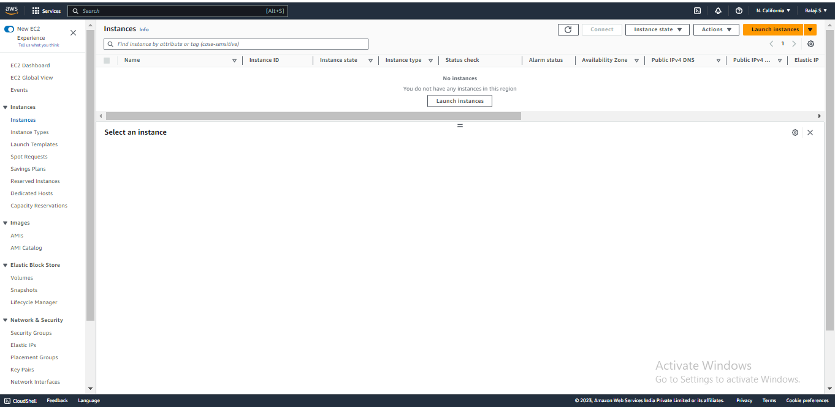

Step 2 :Enter the Name and click on Browse more AMI’s

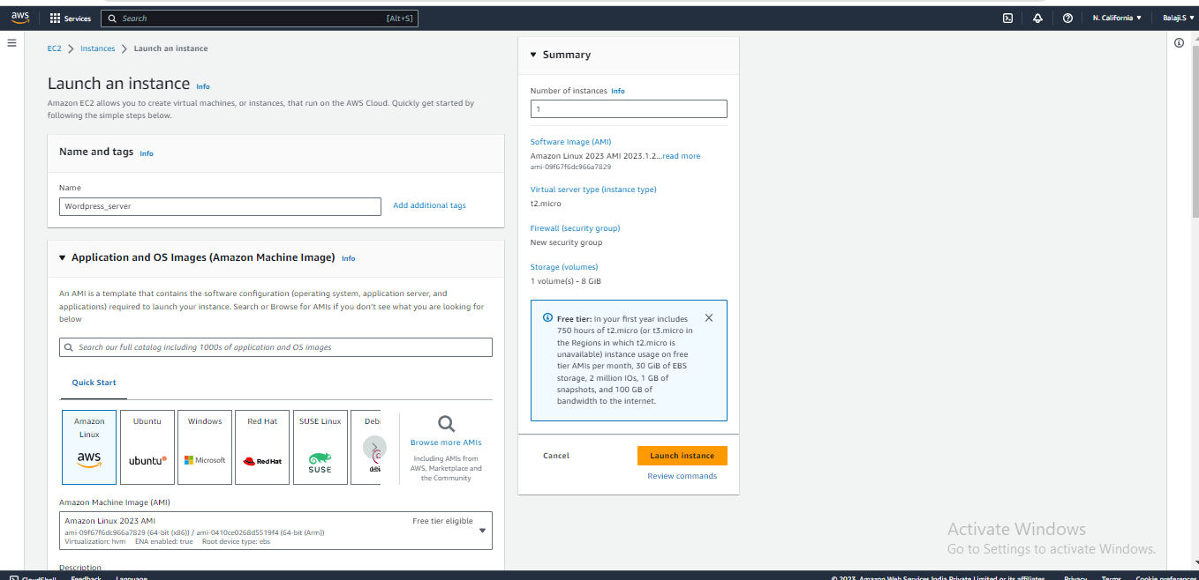

Step 3: Seach for wordpress and click on select.

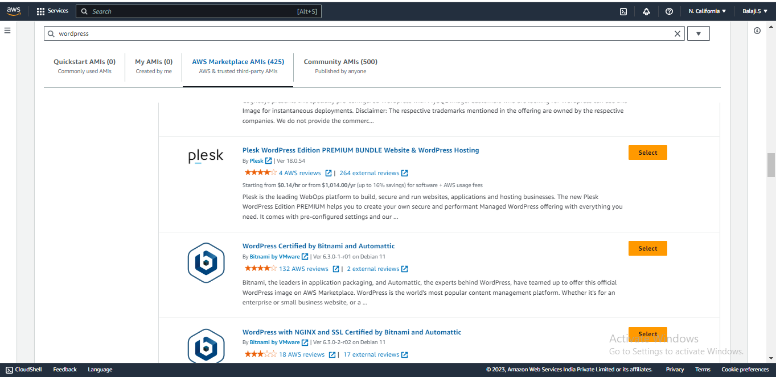

Step 4 : Click on continue.

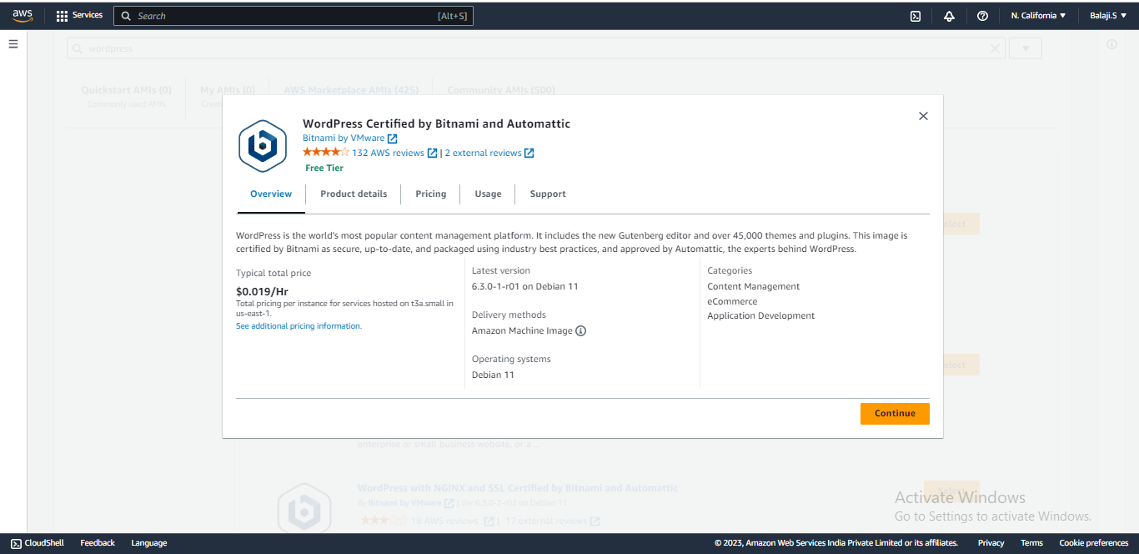

Step 5 : AMI will be selected.

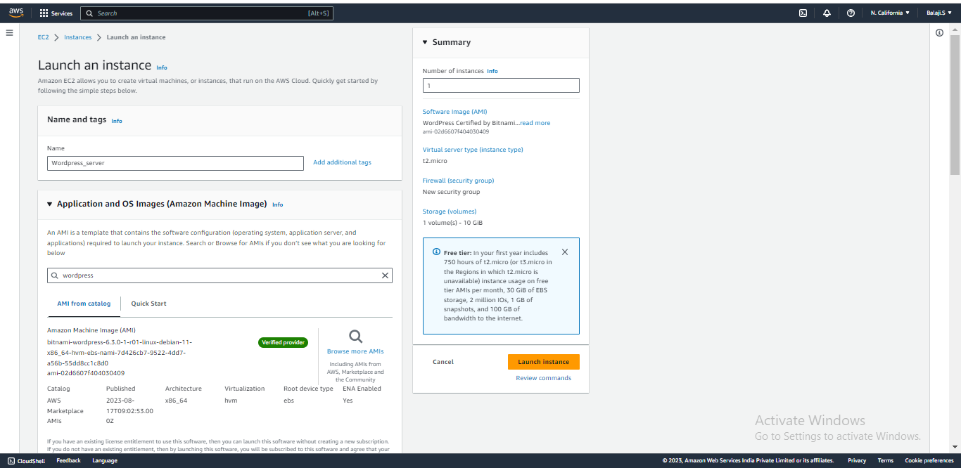

Step 6 : Select the Instance type with only Free-tier and select the key-pair then, click on launch instance.

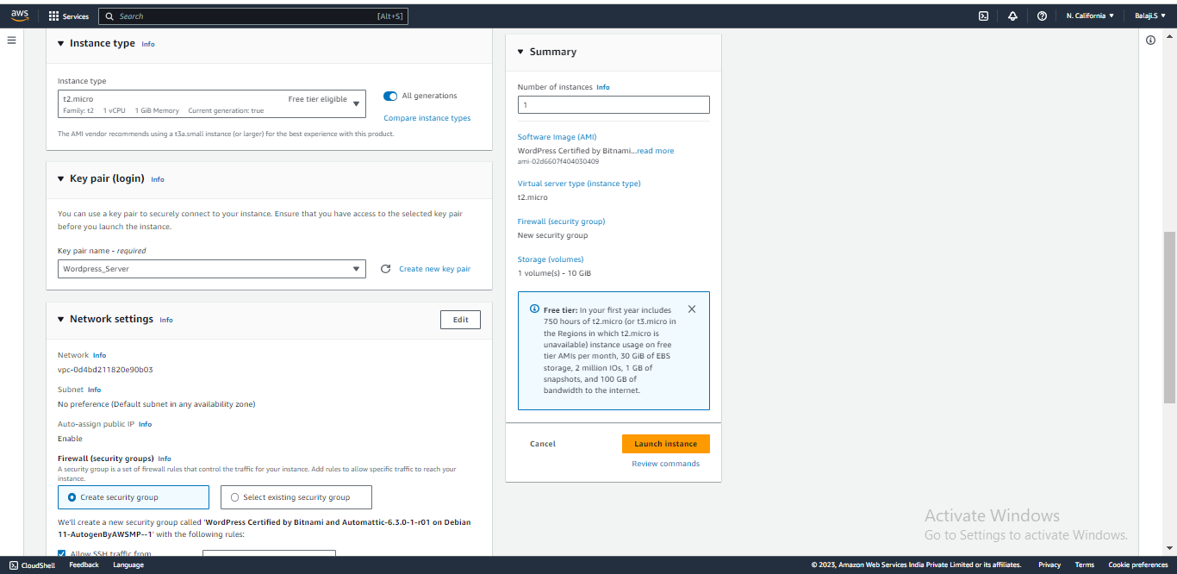

Step 7 : Once Instance is created copy the Public IP and paste it in browser.

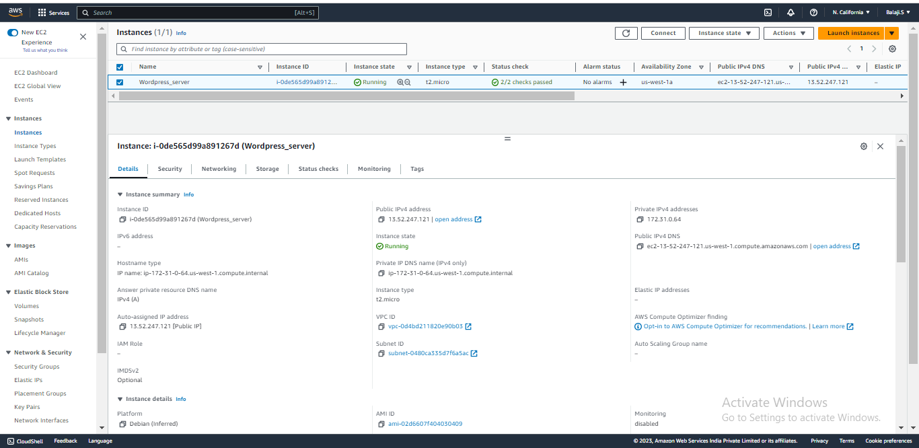

Step 8 : You must get the wordpress page on that public IP address.

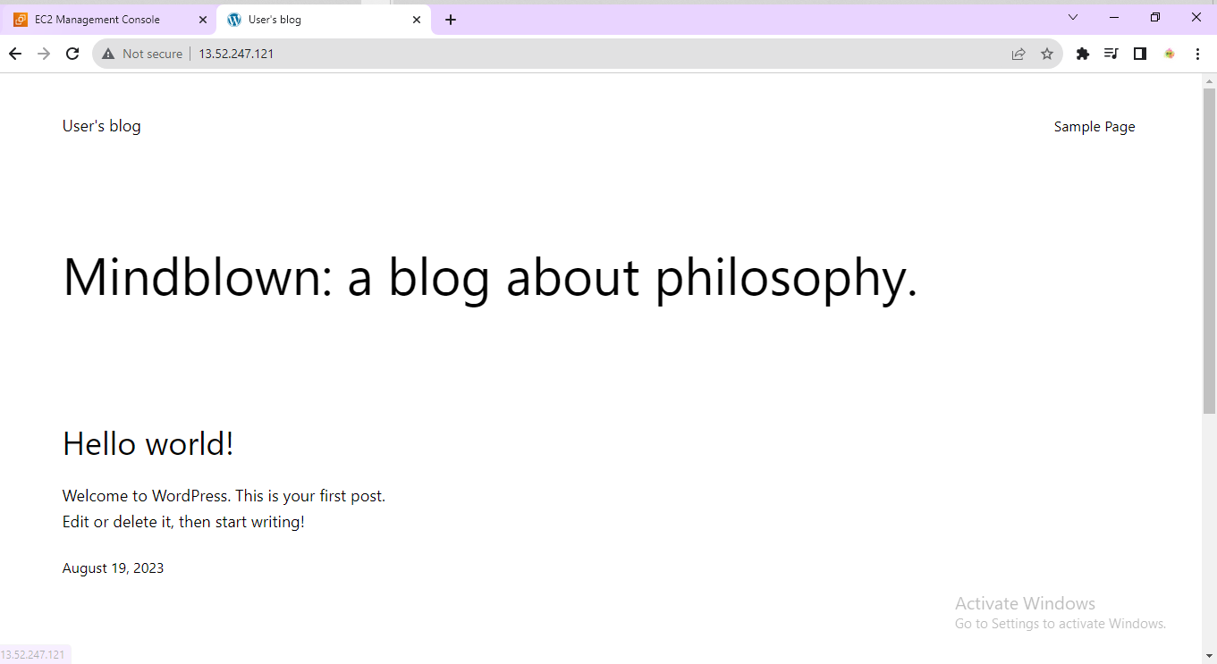

Step 9 : Go to Route 53 service. Click on Create hosted zone.

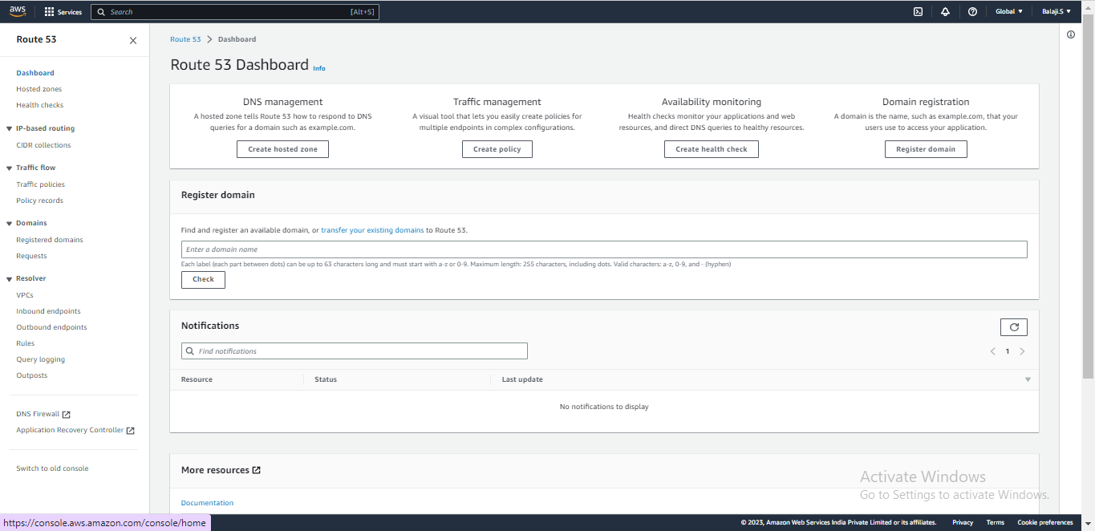

Step 10 : Enter Domian name,description and select the type and click on create hosted zone.

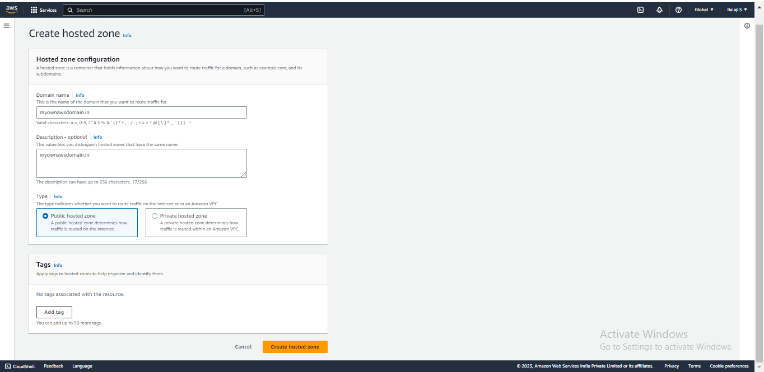

Step 11 : Hosted Zone is created. Click on create record.

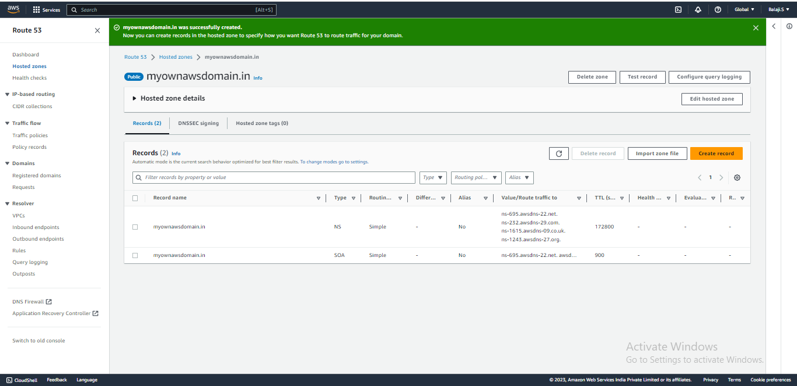

Step 12 : Enter the value as instance Public IP address and select record type and click on add another record.

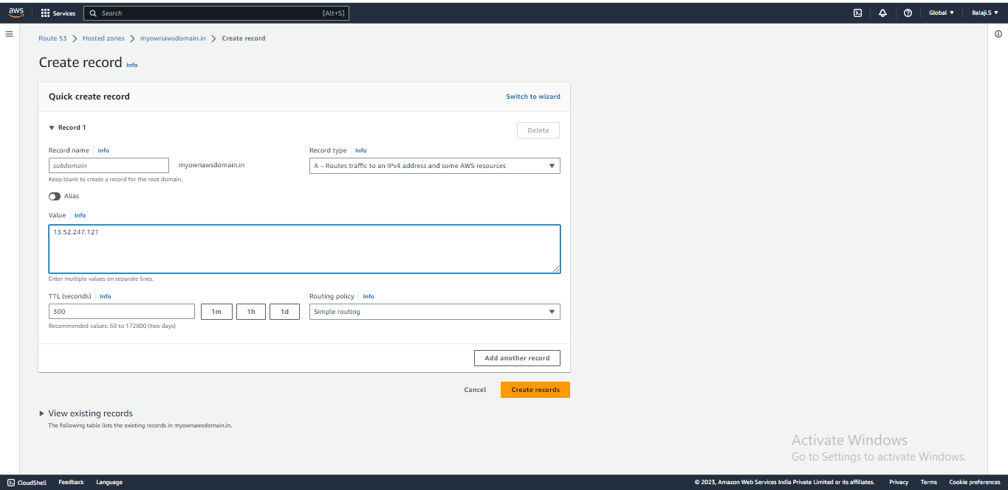

Step 13 : Enter Record name,record type and value then, click on create records.

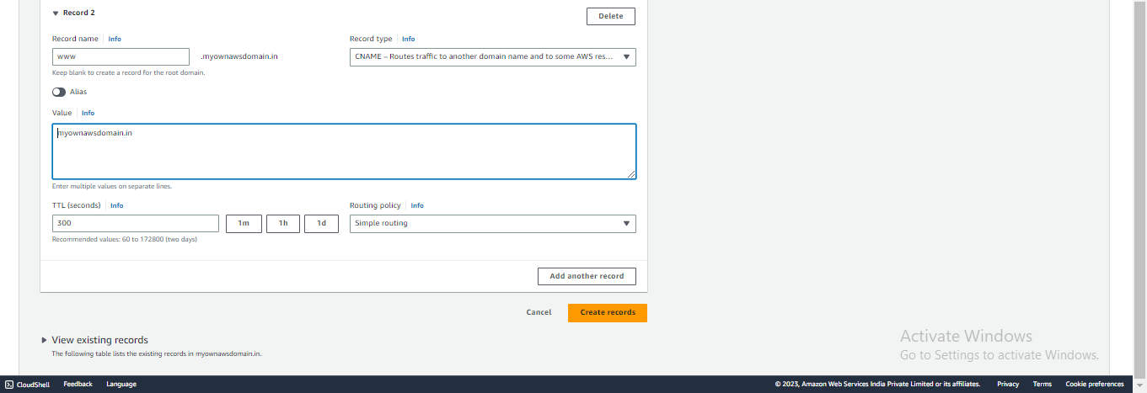

Step 14 : Records is created.

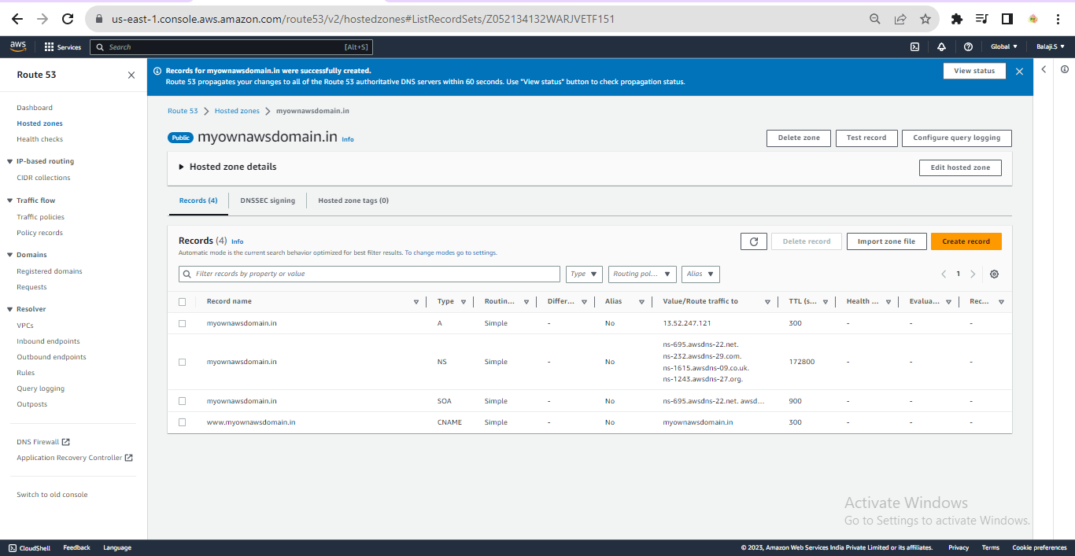

Step 15 : Go to Route 53 and copy the nameservers.

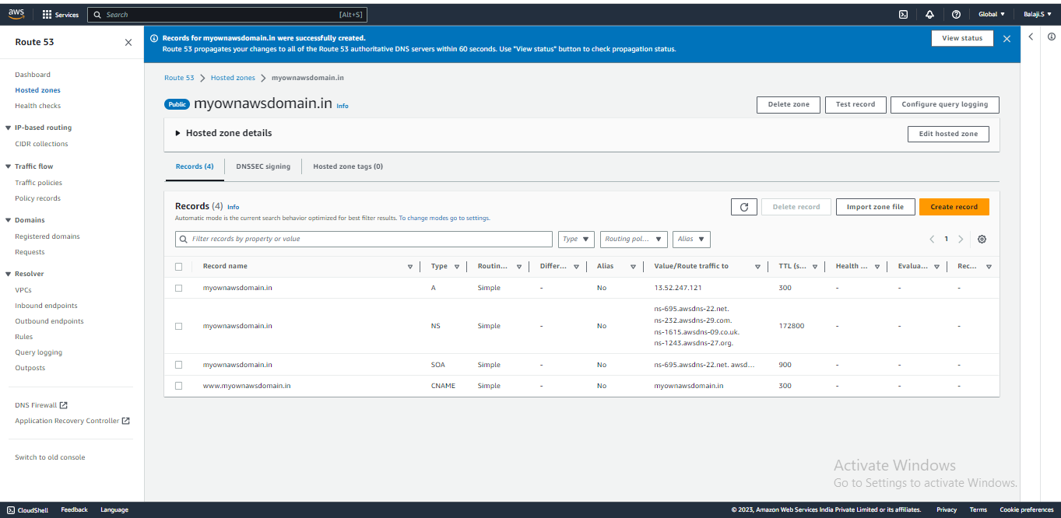

Step 17 : Paste the Nameservsers in DNS Provider website and click on save.

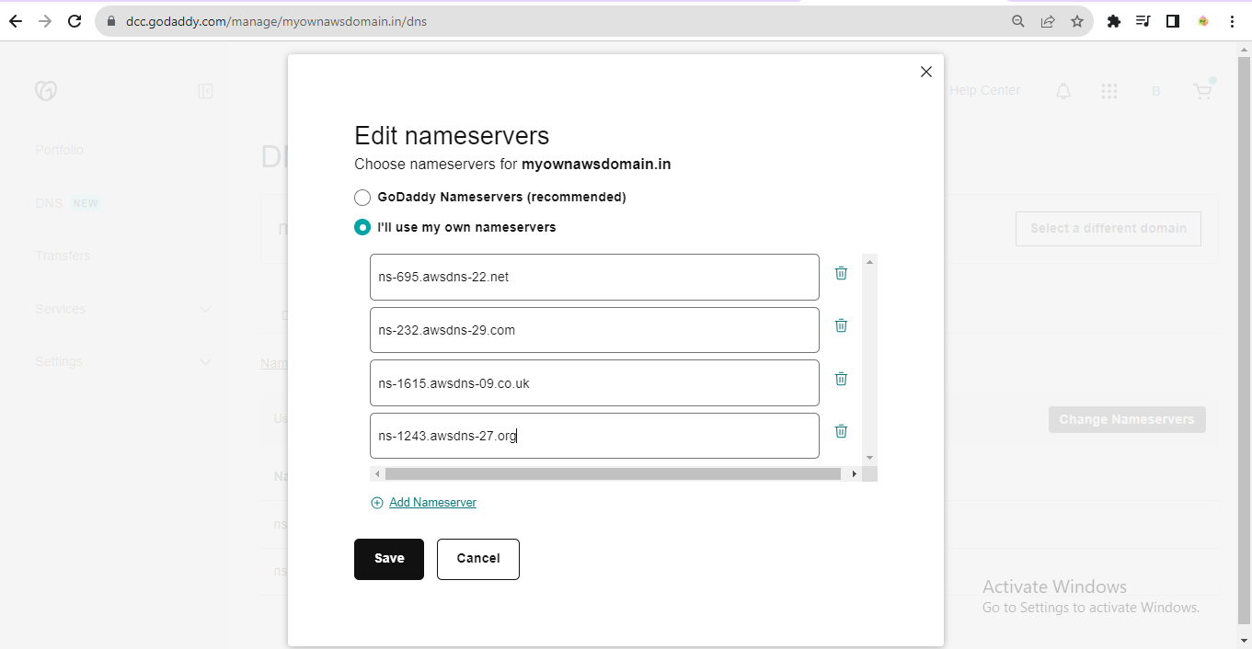

Step 18 : It will take sometime to map the nameservers to our client.

